
Blanket Lapel Pin T- Shirt Post Cards
U.S. Forum of the DKG Society International
ORDER FORM
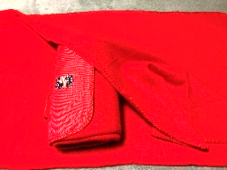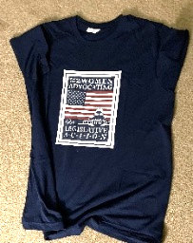

Items for Purchase (* all prices include tax)
Item | Description | Price * | Size | Quantity | Total
Blanket | Soft, cozy blanket that rolls up for easy transport. | $28
Lapel Pin | Decorative logo pin that will be a great addition to your DKG badge. | $3  4 for $10
T-Shirt | Standard cotton T-shirt (dark blue with US Forum logo on chest)  Unisex sizes (“men’s”) | $22 | ____SM  ____ M  ____LG  ____XL
 | Extra large T-Shirt sizes 2X 3X 4X | $25 | ____ 2X  ____3X  ____4X
Chapter Bundle #1 | 5 Blankets, 5 Lapel Pins | $ 140
Chapter Bundle #2 | 5 Blankets, 5 Lapel Pins, 5 T-shirts (standard sizes) | $ 235
Post Cards | 3x5 with address & message spaces on rear- pkg of 32 | $5
ORDER TOTAL (*price includes taxes) |  |  |  | $
SHIPPING (25%) |  | + |  | $
Total Cost (Order with taxes plus shipping) |  | = |  | $

Order Details
Name: ___________________________________________ Email: ___________________________________________
Phone: ___________________________________________
Shipping Address:

Payment Method: __ Credit/Debit Card** __ PayPal ** ___Check # ___________________
** on-line orders only make checks payable to DKG U.S. Forum
ORDER VIA ZEFFY; LINK ON THE WEBSITE STORE PAGE
Mail order form and payment to Linda McCrary P.O. Box 375 Red Boiling Springs, TN or order on-line
at www.dkgusforum.org. and send payment as indicated. Thank you for supporting the U.S. Forum.

